

Linnaeus University

1DV532 – Starting out with Java

Assignment 3 Report

Student: Evan Huynh

Student ID: eh223im@student.lnu.se

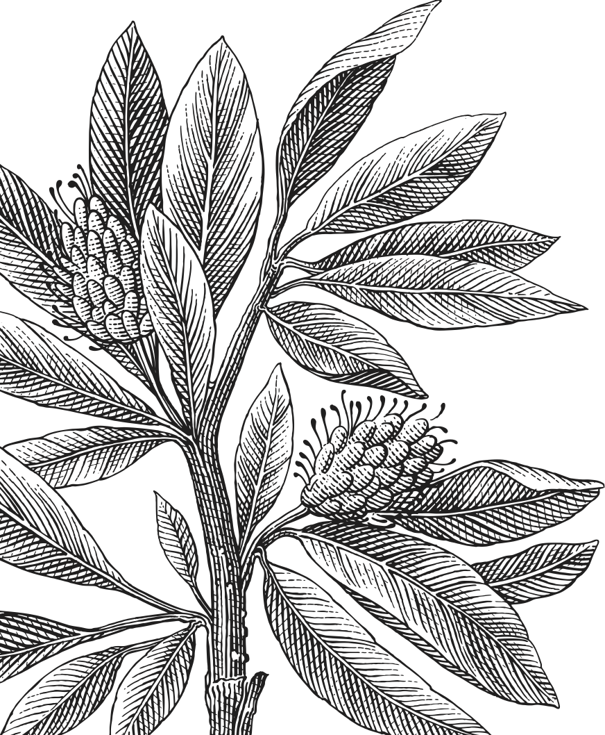

Table of Contents

Report 3

Exercise 1: Dice 3

Exercise 2: Person 3

Exercise 3: Message 3

Exercise 4: Number 3

Exercise 5: Name 3

Source code 4

Bibliography 4

# Report

## Exercise 1: Dice

In this exercise, the main idea is to create two variables for two dice then another variable to sum them up. After each turn, we add 1 into each value of the array recorded result and export it in the appropriate form.

## Exercise 2: Person

A

## Exercise 3: Message

A

## Exercise 4: Number

A

## Exercise 5: Name

A

# Source code

Here is my source code for all the exercise.

|  |
| --- |
| 1 |
| Dice.java  package eh223im_assign3;  import java.util.Random;  public class Dices {  public static void main(String[] args) {  int a1, a2, a3;  Random r = new Random();  int[][] b = new int[11][2];  for (int i = 0; i<b.length;i++) {  b[i][0] = i+2;  }   for (int i = 0; i<10000; i++) {  a1 = r.nextInt(6) + 1;  a2 = r.nextInt(6) + 1;  a3 = a1 + a2;  b[a3 - 2][1] += 1;  }   for (int i = 0; i<b.length;i++) {  System.*out*.println(b[i][0]+"\t"+b[i][1]);  }  } } |
| 2 |
| Person.java |
| PersonMain.java |
| 3 |
| Message.java |
| MessageMain.java |
| 4 |
| Numbers.java |
| 5 |
| Names.java |

# Bibliography

|  |  |
| --- | --- |
| [1] | Brilliant.org, "Finding The Number of Digits," 16 June 2020. [Online]. Available: https://brilliant.org/wiki/finding-digits-of-a-number/. |